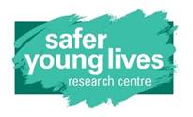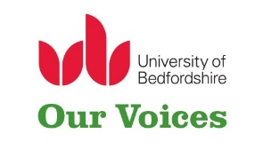

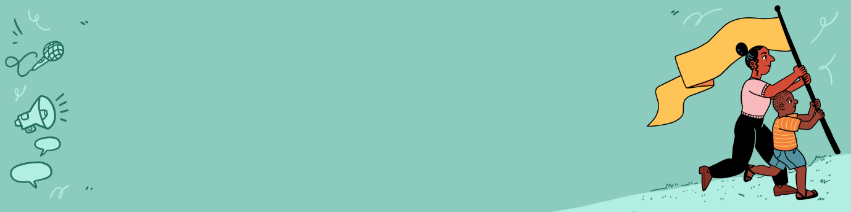

## Template: Young People’s

## Consent Form

|  |
| --- |
| This form has been adapted from those originally developed by staff at the Safer Young Lives Research Centre at the University of Bedfordshire. Those wishing to use this template should reflect on how suitable it may be for their own project and context and make the necessary adaptations. |

Before you take part in the XX project we need to make sure you understand what the project is about and what is being asked of you.

Please read the statements below and place an **X** in the box if you agree.

If there is anything you’re not sure about, get in touch and we can answer any questions.

|  |  |  |
| --- | --- | --- |
| 1 | I understand what the project is about. |  |
| 2 | I have had the time to think about, and ask questions about the project. |  |
| 3 | The idea of ‘ongoing consent’ has been explained to me and I know that I will only be asked for my written consent at the beginning of the project. I understand that consent will be discussed throughout the project to check I am still happy to take part. |  |
| 4 | I understand that my participation is voluntary and that I don’t have to answer questions or take part in all the activities. I know I am free to withdraw from the project at any time and do not need to provide a reason why. |  |
| 5 | I understand that if I share information during the sessions, but decide that I don’t want you to include it in any reports, that I have X weeks to let you know so that this can be removed.  I also understand that in group discussions and activities it may be hard for the team to know exactly ‘who said and contributed what’ so you may not be able to remove every contribution I have made. |  |
| 6 | I understand that you cannot use everything I say in the resources that are developed as part of this project. |  |
| 7 | I understand that some of what I say, and what I develop during the activities may be used in blogs, presentations, toolkits, reports and XXXX that will be shared widely with different groups of people to raise awareness about the topic. |  |
| 8 | I understand that information I share will remain confidential to the project **but that if I disclose that someone is being harmed or at risk of serious harm, the team will have to pass this on.** |  |
| 9 | I know that you won’t use my name or anything that would let people know that it was me that took part in the project. **However, I understand that if I choose to take part in related events/ activities within the community that my participation and identity will not remain private and confidential.** |  |
| 10 | I have seen the privacy statement, and know how you will keep my information safe. |  |
| 11 | I understand that I have the option to receive future information and updates about the project. |  |
| 12 | I know that if I chose to, I may be contacted and invited to take part in events or discussions about the project once the project ends. |  |
| 13 | I know who to contact if I wish to change my mind about receiving information, or being contacted in the future, about the project. |  |
| 14 | I know who to contact if I have any questions or concerns. |  |

Your name:

Date: Signature:

**Consenting**

I agree to take part in this project.

Yes    ☐          No ☐

How would you like us to record the discussions? (tick one)

Audio-recorded    ☐

Hand written notes ☐

I agree for you to use things that I say, or pictures/film I create, in project outputs such as: blogs, presentations, toolkits, films and reports.

Yes    ☐          No☐

I would like to be kept up to date about the project and what happens next.

Yes    ☐          No☐

If yes, I would like you to share information with me via:

Email ☐

Text    ☐

Phone ☐

Post ☐

Via someone else ☐

Please give your chosen contact details (e.g. the address, number, name of the person you would like updates to be shared with)

***Once you have filled in this form, please return this to the person who gave it to you.***

|  |
| --- |
| If adapting this template and making it publicly available, then please include a source statement. Suggested statement ‘Adapted from Our Voices (2025)Template: Young People’s Consent Form. Safer Young Lives Research Centre, University of Bedfordshire’. |