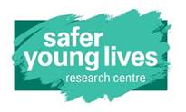****

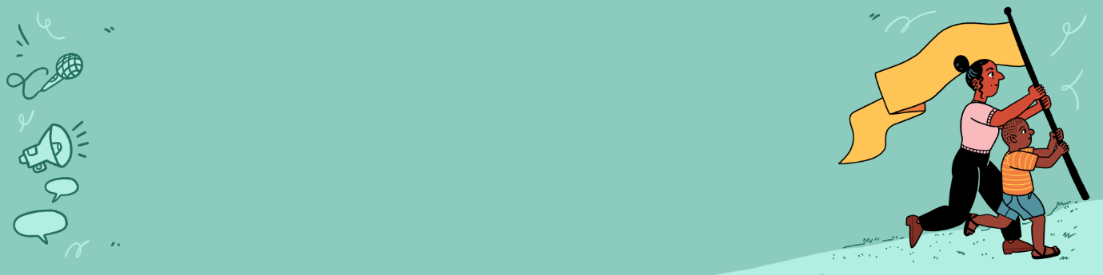

## 

## Template: Risks, needs and benefits

## discussion guide

|  |
| --- |
| This resource has been adapted from assessment forms originally developed by staff at the Safer Young Lives Research Centre at the University of Bedfordshire. This resource takes on board findings from research undertaken as part of the Our Voices programme, particularly around the need for young people to be involved in these initial discussions. Those wishing to use this resource should reflect on how suitable it may be for their own project and context and make the necessary adaptations. |

## Step 1: Anonymised discussion between facilitator/ researcher and support worker/case manager for the young person

|  |  |
| --- | --- |
| ***Initials of young person:*** | ***Notes*** |
| Area of focus |  |
| How long since the young person has been free from the abusive/ harmful situation/relationship? |  |
| Has the young person received any support due to these experiences of harm? If so for how long and what type of support has been accessed? |  |
| Is there a current legal case ongoing? If so, at what stage is it and how might participation impact the case? |  |
| Are there any concerns about current life stressors/ life events? (e.g. exams, work, family) |  |
| Is the young person currently living in a safe situation? e.g. are not in an exploitative/ abusive situation and have their basic needs met |  |
| Is there a risk that their engagement in the project may increase stigma or harm in any way? If so are there measures that could be taken to prevent that? |  |
| Has the young person been involved in any other projects/ similar activities where they have been asked to share their views? If yes, how did they find it? |  |
| Why do you think the young person would like to be involved? Do you think they may benefit from taking part? If so, in what ways? |  |
| Do they have a support network or someone they can talk to if they need to? |  |
| Are there any adjustments that could be made to help the young person engage? e.g. would they need an interpreter, materials to be presented in a certain way? |  |
| Any other information that would be useful for the project team to know? |  |

## Step 2: Discussion between facilitator/researcher and young person

|  |  |
| --- | --- |
| ***Initials of young person:*** |  |
| Area of focus |  |
| *[Explain the project]* | |
| **Do you have any questions about taking part in the project?** |  |
| ***Exploring concerns or fears.***  *[If they don’t have any questions, to kick start the discussion you may want to talk about what some people might find difficult e.g. some people might be worried that talking about abuse and harm may be upsetting; some people might worry that other people might find out that they took part in the project.]*  *Following this, you could explain what steps you are taking to minimise such concerns.*  **Do you think you might have any concerns or worries if you were to take part in the project?** |  |
| ***Exploring how to make their engagement more comfortable.***  **If you did choose to take part, is there anything I could do to make it easier for you/ help you feel more comfortable?**  *[If they don’t say anything, you could explain that some people might find it easier to spend time getting to know each other in the group before talking about difficult topics, or that some people may find it helpful to know that they do not have to share anything personal about their own experiences in the group]*  **Would any of those things help make it a better experience for you?** |  |
| ***Exploring if there is anything they would not like to discuss.***  *[You can explain some of the topics or themes that might come up during the project but that there may be other topics of conversation that you might not plan to talk about but do come up naturally. But that If you are aware of topics that might be too difficult you can think about how to manage this situations as a facilitator]* |  |
| ***Exploring motivations for taking part.***  *[Note again that, as you said before, there are always potential risks in taking part in a study like this, as some people may find it difficult to remember the past or find parts upsetting, but share that people taking part in research studies or other projects that aim to help other young people can find it motivating and a positive experience]*  **Would you be happy to share why you are interested in taking part?** |  |
| ***Exploring support in place.***  **Do you have someone you could speak to, or ways to access support if you did feel upset?** |  |
| ***Practical details***  **If you are interested in taking part, is there somewhere you prefer to meet?**  **A day/time that works best for you?**  **Anything else we could do to make it easier for you?** |  |
| ***Other***  **After thinking more about the project, do you have any questions?** |  |
| **Is there anything else that you think it would be useful for me to know?** |  |

|  |
| --- |
| If adapting this template and making it publicly available, then please include a source statement. Suggested statement ‘Adapted from Our Voices (2025) Template: Risks, needs and benefits discussion guide. Safer Young Lives Research Centre, University of Bedfordshire’. |