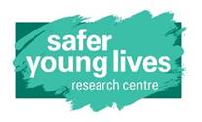****

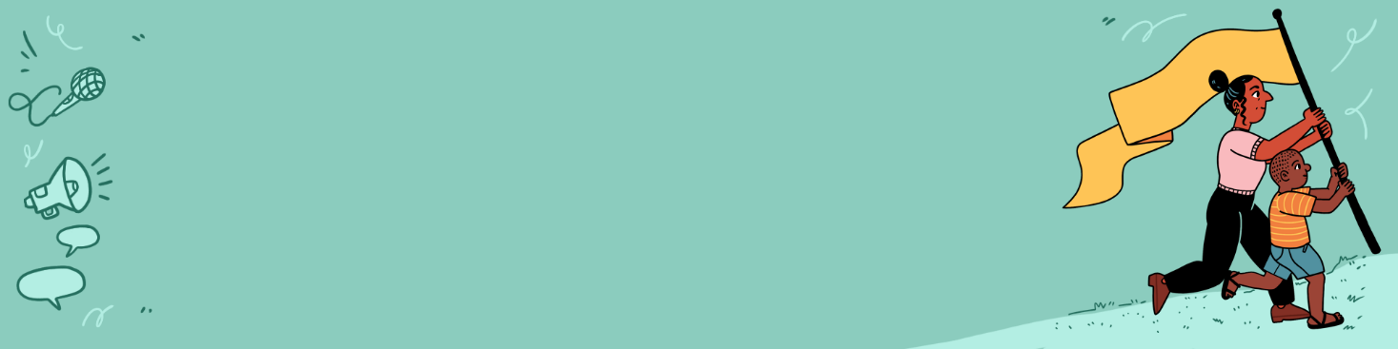

**Template: How can we enact**

**trauma-informed**

**principles in our project?**

|  |
| --- |
| This planning tool has been developed by staff at the Safer Young Lives Research Centre at the University of Bedfordshire. Those wishing to use this resource should reflect on how suitable it may be for their own project and context and make the necessary adaptations. |

|  |  |  |
| --- | --- | --- |
|  |  |  |
| **Common impacts of experiencing childhood sexual violence** | **Trauma-informed principles** | **What can we do to respond to these potential impacts and promote trauma-informed principles in our project?** |
| Loss of sense of safety | Establish safety | *Example:*   * *We can work with the individual young people involved to put safety plans in place and ask young people about what safety means to them in relation to this project.* * *We can identify which locations young people feel safe travelling to and meeting as a group* * *We can plan for, and include enough budget so that young people can access additional psychological support they may need from participating in the project (and with therapists / support workers, they have an established safe, relationship with).* |
| Distrust | Build trustworthiness and transparency |  |
| Isolation, shame and stigma | Provide opportunities for peer support |  |
| Lack of confidence and self-esteem | Value mutuality and collaboration |  |
| Loss of choice and control | Prioritise empowerment, voice and choice |  |
| … *may be enhanced by certain circumstances, characteristics* | Be attuned to cultural, historical, and gender issues |  |

|  |
| --- |
| If adapting this template and making it publicly available, then please include a source statement. Suggested statement ‘Adapted from Our Voices (2025)Planning tool: How can we enact trauma-informed principles in our project? Safer Young Lives Research Centre, University of Bedfordshire’. |